School Newsletter

No.02 - Term.01, Week 03 – Monday 12 February 2018

Greetings, Kia ora, Talofa lava, Kia orana, Malo e lelei, Fakalofa Lahi Atu, Namaste, An Young Haseyo, Konichiwha, Bula Vinaka, Sawadee, Dobra Dan, Ni Hao, As-salamu alaykum, Hola

From the Principal – Mrs. Watts

Thank you to everyone who attended the parent evening on Wednesday night. We enjoyed meeting with you and look forward to working alongside you all.

Introducing: the 2018 head boy and head girl
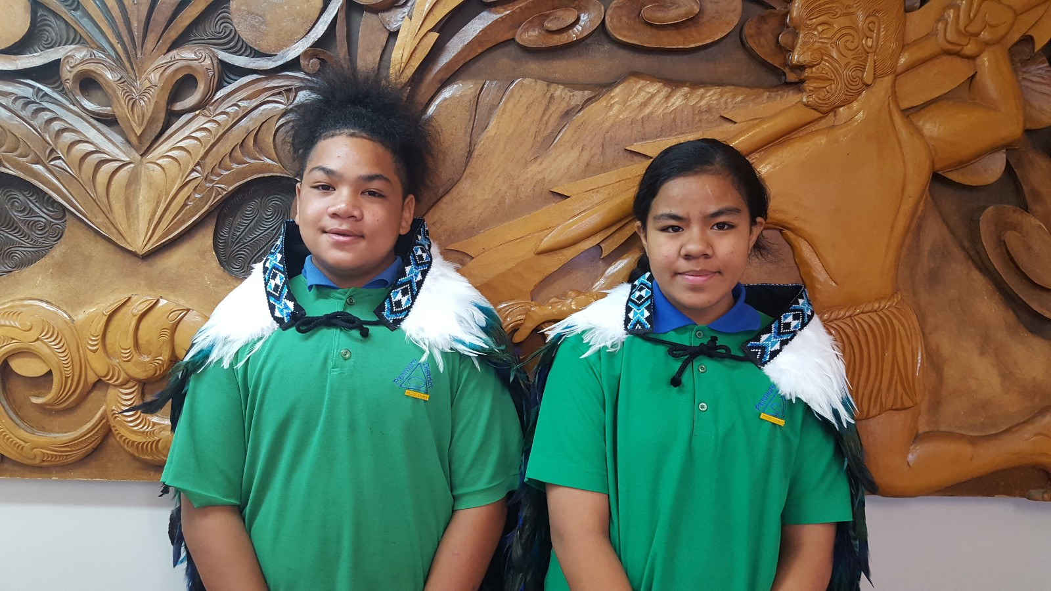
Head boy: Faioso Uilou, Head Girl: Monalisi Tupou

2018 Student Council
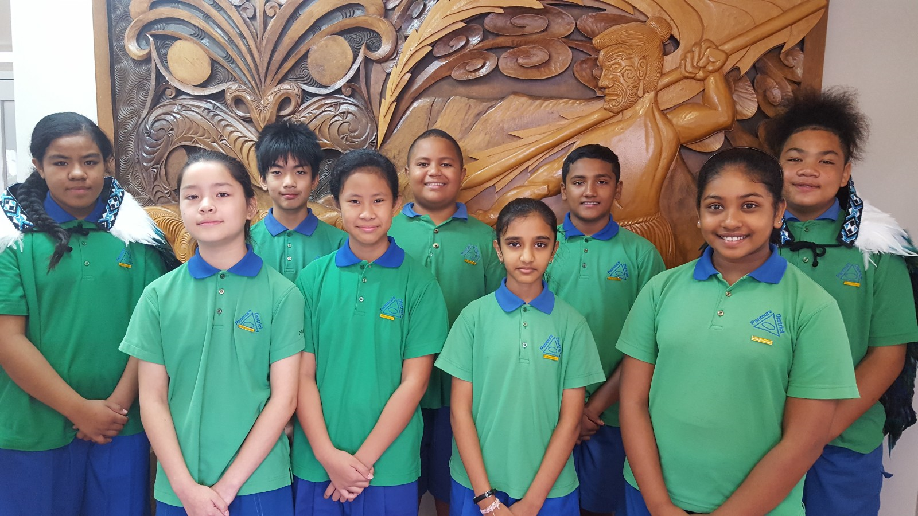

Left to right - back row: Monalisi Tupou, Benja Wamontree, Toapasi Toki, Krrish Narayan, Faioso Uilou. Front Row - Micaela Lizasoain Ren, Razel Padayao, Krishna Patel, Dipasha Prasad

Panmure District School Baking Programme
Is starting up again on Wednesday 14 February in our school hall from 9am onwards. All are welcome.

Winning House for weeks 1 and 2
Congratulations Rata House!!! Your house flag is flying high.

Singing Assembly
We had our first house singing assembly for the year. This will be every fortnight.
This Friday 16 February will be our formal assembly hosted by Room 7 (Year 6-8) - Miss Jessie’s class.

Gymnastics
Our KiwiSport Gymnastics Instructor Kane is helping some Year 3 students do a forward roll.

Play based learning
Our junior school team - Te Kai a Hiku, had a great time learning through play. Please feel free to come and join us in Room 4 Mondays and Thursdays at 1:30pm.

Can you help?
We’re looking for parents who are able to:
-supervise a Friday after-school year 7/8 Rippa Rugby team. There are on-site coaches who will coach the team during the week - we need parent/s who are able to accompany the team to the Mt Wellington Rugby Club for their weekly Friday after school game
-help transport 2 year 7/8 (mixed) softball teams to
Mt Wellington War Memorial on Wednesday 21 February
-donate toys, buttons, dice, counters, empty food boxes for our junior school play based learning class.

If this sounds like you, please speak to our friendly receptionists Mrs Kamuhemu and Mrs Karan.

Review of Home Study Policy
Have your say about homework:

Visit the website
http://panmure.schooldocs.co.nz/1893.htm

-Enter the username (Panmure) and password (rise).
-Follow the link to the relevant policy as listed.
-Read the policy.
-Click the Policy Review button at the top right-hand corner of the page.
-Select the reviewer type "Parent".
-Enter your name (optional).
-Submit your ratings and comments

If you don't have internet access, school office staff can provide you with printed copies of the policy and a review form.

Student Information Update
In case of an emergency, it’s important that we have up to date information for all children. Please fill in the attached sheet and return to school as soon as possible. Please also include your email address so that school newsletters can be emailed to you.

Reminders:
Swimming: every Monday in our school pool. Students will need named togs, towel and a plastic bag
Breakfast Club: Daily. 8 Am. School Hall. All are welcome
Book Bags: Need to be brought to school daily
Uniform and stationery: Are still available to be purchased from the school office. More school hats have been ordered
Naming school uniform: Please remember to name all items including school bags, water bottles and lunchboxes.

If your child attends Panmure District, is aged between 5 and 12 years old and is interested in playing for the Auckland University Rugby Football Club and you need financial assistance to help with Ruby gear, please see the school office for more information.

